(Community Organization and/or Business Name)
(Address)
Dear______, (Date)

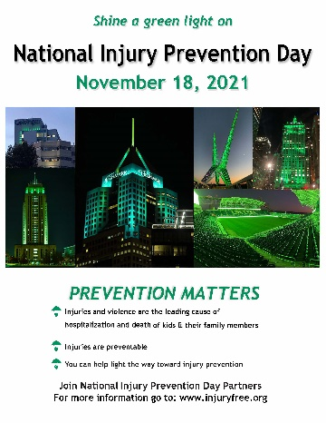
The Your Organization, is working to address needless injuries and violence taking place in Your Service Area. Did you know that every day 20 children needlessly die from preventable injuries – and their deaths make up more deaths than all other diseases combined? Their family members are also dying and being hospitalized. Injury is the number one cause of death and hospitalization of people from 1-44 years old and we are asking you to help make a difference. “Shine a Green Light” on November 18th, 2021, National Injury Prevention Day, to help raise awareness about the need for change.
Across the country, some of the nation’s leading injury and violence prevention organizations will come together to raise awareness about the burden of injury and violence. They will join forces to push for change on the 2nd annual "National Injury Prevention Day." It is our hope that you will take part. By stepping up you will be joining Injury Free Coalition for Kids®, Safe Kids Worldwide, Safe States Alliance, the American Trauma Society, the American Academy of Pediatrics, BeSMART a division of Everytown for Gun Safety, the Society for Advancement of Violence and Injury Research, the Trauma Centers of America Association and JPMA Cares of the Juvenile Products and Manufacturers Association. To take part go to https://injuryfree.org/nationalinjurypreventionday/2021/ and look at the community events. If you are interested in hosting an event for National Injury Prevention Day, contact estelljohnson@sbcgloabl.net with any questions. You can list your own NIPD events by submitting them at https://injuryfree.org/admin/nipdprogram_edit.cfm.

We ask you to do what you can in this nationwide effort. Make sure buildings and city landmarks shine green lights, take part in Injury Prevention events in your community, and join the Twitter chat with @InjuryFreeKids using the hashtag #BeInjuryFree at 1:00 pm EST on November 18th.
The good news is that many of injuries and acts of violence suffered are preventable with the use of safety practices, products, and policies. Our children, our young people and their families want to live injury free and thank you for your support.
Sincerely,

Your Signature
You Title
Your Organization

