Join Us: Shine a Green Light
National Injury Prevention Day Partners

Partner Logo

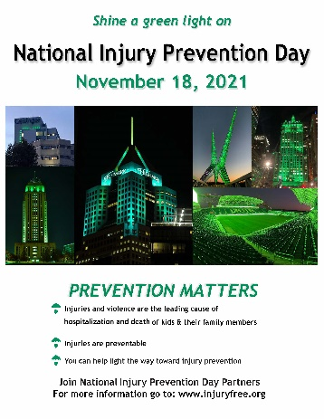
Did you know that injuries are the leading cause of death and disability to U.S. children 1-18 years old? Every day, 20 children needlessly die from preventable injuries. Injury and violence. It is the number one case of death until they are 44 years old. Injuries lead to more deaths than all other diseases combined. There is good news. Many of these injuries are preventable with the use of safety practices, products, and policies. That is why the country’s top Injury and Violence Prevention Organizations are joining forces on National Injury Prevention Day on Thursday November 18th, 2021, and we would like you to join us.

Community Outreach Activities

Across the country, some of the nation’s leading injury and violence prevention organizations will come together to raise awareness about the burden of injury and violence. They will join forces to push for change on the 2nd annual "National Injury Prevention Day." It is our hope that you will take part. By stepping up you will be joining Injury Free Coalition for Kids®, Safe Kids Worldwide, Safe States Alliance, the American Trauma Society, the American Academy of Pediatrics, BeSMART a division of Everytown for Gun Safety, the Society for Advancement of Violence and Injury Research, the Trauma Centers of America Association and JPMA Cares of the Juvenile Products and Manufacturers Association. To take part, go to https://injuryfree.org/nationalinjurypreventionday/2021/ and look at the community events. If you are interested in hosting an event for National Injury Prevention Day, contact estelljohnson@sbcgloabl.net with any questions. You can list your own NIPD events by submitting them at https://injuryfree.org/admin/nipdprogram_edit.cfm.

Be a part of the Twitter Chat

In addition to various activities and events, a one-hour Twitter chat will take place at 1:00 pm EST on November 18th, discussing the urgent need to prevent injuries and how everyone can play a role. To join the conversation, follow us @InjuryFreeKids and use the hashtag #BeInjuryFree. Topics to be discussed include injuries caused by motor vehicle crashes, drownings, poisonings, firearms, sleep related infant suffocations, and other injuries often seen in emergency departments across the country.

Shine a Green Light

On Thursday, November 18th, 2021, as the sun goes down across the nation, and a day of community outreach comes to a close, city landmarks will take on a new look. Trauma Centers, businesses, bridges, government buildings and neighborhood homes will shine a green light. You can shine one as well and then send a photo so that we can show how you shared in lighting the way toward change.

In addition to creating a green skyline the organizations will be in communities working to make a difference.

When the sun goes down, please shine a green light to help raise aware about the significance of Childhood Injuries and light the way toward change. For more information call 816-651-7777.
The Injury Free Coalition for Kids is a part of the outreach arm of the ICRC located in the Columbia University Center for Injury Science and Prevention

