National Injury Prevention Day 2024
Proclamation Request Guide

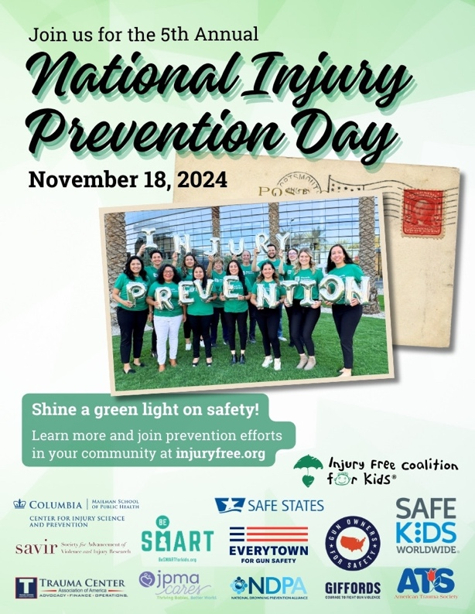
Proclamations and certificates of recognition are another way to put the spotlight on National Injury Prevention Day. Mayors, City Managers, Governors, and Presidents can all issue proclamations and frequently read them out loud at events. Senators and representatives may issue certificates of recognition to groups or individuals.

Today, many public officials will have a webform available on their website which you can use to request a proclamation for your National Injury Prevention Day event. However, you may need to request a proclamation in writing and the public official will more than likely need your help writing it. This resource includes tips on what to include in your proclamation as well as a template to get started.

- Check the website of the public official from whom you are requesting the proclamation. They may have a system and process that you should follow. If you need to submit your request in writing, see below for our checklist of what to include in that letter.
- Consider including a data point specific to your state, county, region or city. You may want to have some statistics just for this year as well as an overall statistic for all the years that statistic has been measured, or to a comparable national measure.
- Don’t forget to call attention to the events your coalition and local partners working will be holding to mark National Injury Prevention Day.
- Act early and follow up! It’s always a good idea to make sure you give plenty of lead time in submitting your request. Once you’ve submitted your request, don’t forget to report this at injuryfree.org so that all the proclamations nationwide can be tracked.

Proclamation Request Letter Checklist
Your letter/email requesting a proclamation for National Injury Prevention Day should include:
- Your formal request for consideration of DAY and DATE of the event.
- The date by which you need the request for the proclamation approved. Typically, we encourage coalitions to give eight weeks lead time to be on the safe side.
- Daytime contact information—name and phone number—for the point person who is responsible for the proclamation.
- A brief draft of your proposed proclamation.
- Follow up with the public official’s office after you have submitted the above items.
PROCLAMATION TEMPLATE
that November 18 is National Injury Prevention Day in [CITY]
WHEREAS, injuries are the leading cause of death and disability to U.S. children ages 1 to 18; and
WHEREAS, [Datapoint/Anecdote on Local Impact of Injury]
WHEREAS, the city of [CITY] is committed to creating a safe environment contributing to the safety and well-being of our children; and
WHEREAS, hospitals, state agencies and community organizations are committed to their crucial role in reducing injuries and deaths by promoting safe practices; and
WHEREAS, National Injury Prevention Day raises awareness and promotes efforts to reduce injuries among children; the City of [CITY] commends [Local Partners Sponsoring Request] and all involved in their endeavor to protect children from injury;
NOW, THEREFORE, I, [NAME], Mayor of [CITY] do hereby proclaim November 18 as
National Injury Prevention Day
and call upon the residents of [CITY] to join with me in this observation by [Local Call to Action].

